In-Class Lab 2.0

Penetration Testing with Metasploit

Rationale
To be able to defend a network or system it is necessary to understand what must be mitigated. This lab calls for you to use some of the tools that are used to examine systems, looking for vulnerabilities.
To complete this lab you need to have a target machine installed in virtualbox. Install metasploitable 2 for your virtual box.
Follow the instructions https://www.geeksforgeeks.org/how-to-install-metasploitable-2-in-virtualbox/

Install Armitage to your Kali Linux machine
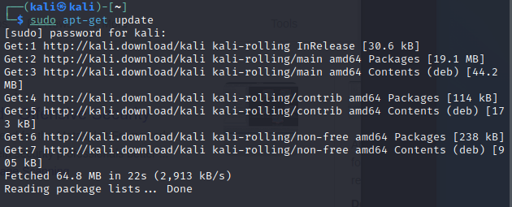
After you are done with the update install Armitage.
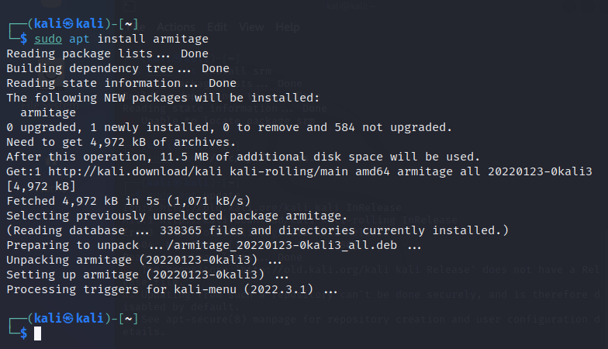

Armitage as a front end to Metasploit

The database must be run in root mode.

Run Kali Linux. Open a shell. Execute the command
sudo /etc/init.d/postgresql start
to start the database server that is used my metasploit. Next, execute sudo armitage as shown here:
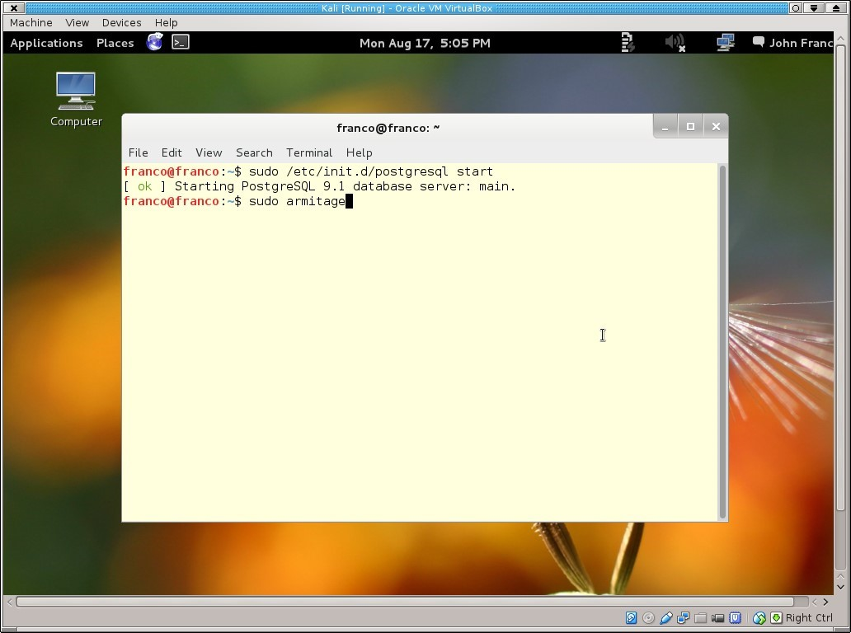
A dialog box appears as shown below. Just click "connect".
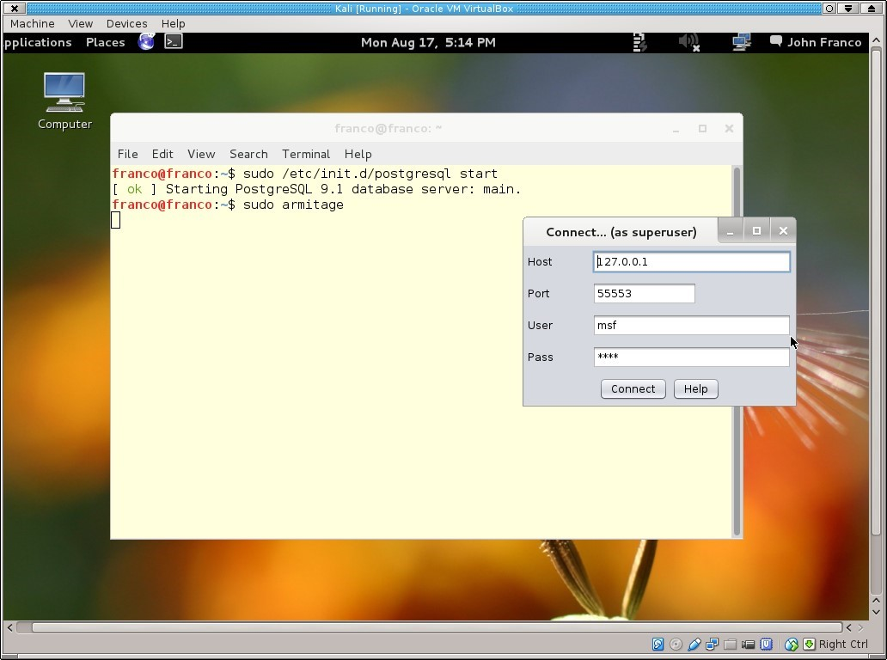
Armitage takes a long time to start. For a while you see this:
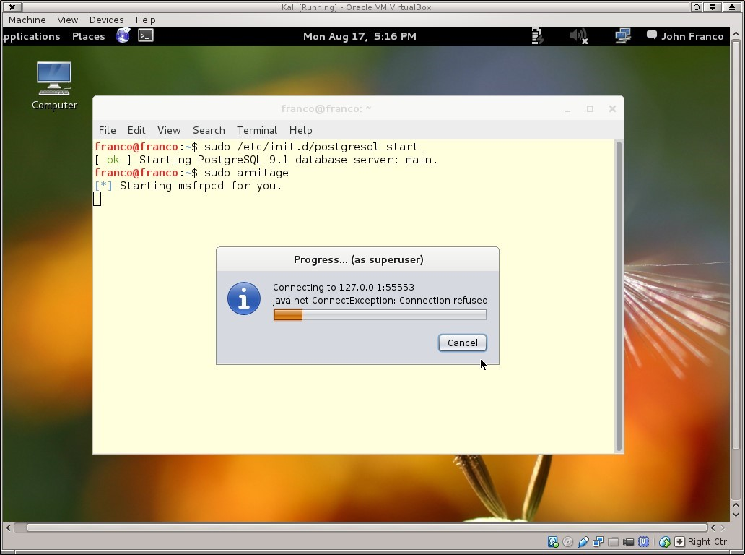
The exception appears because the metasploit framework is not ready for connections. Eventually, a connection is made and the following screen appears, except without the two icons that represent discovered machines from previous launches of armitage.

You might have the following if you completed scans before:
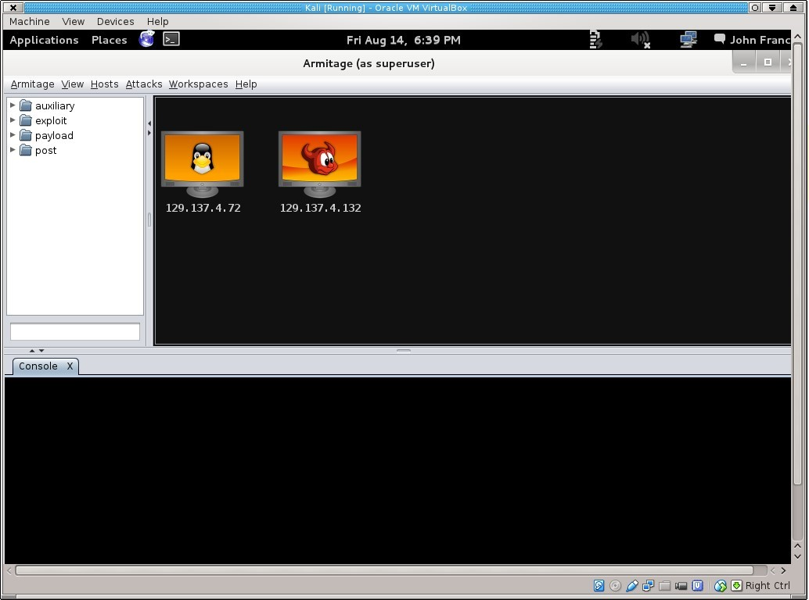
But if you haven’t completed any scans before you will have empty box.
You may have the following menu of Armitage (without target machines).

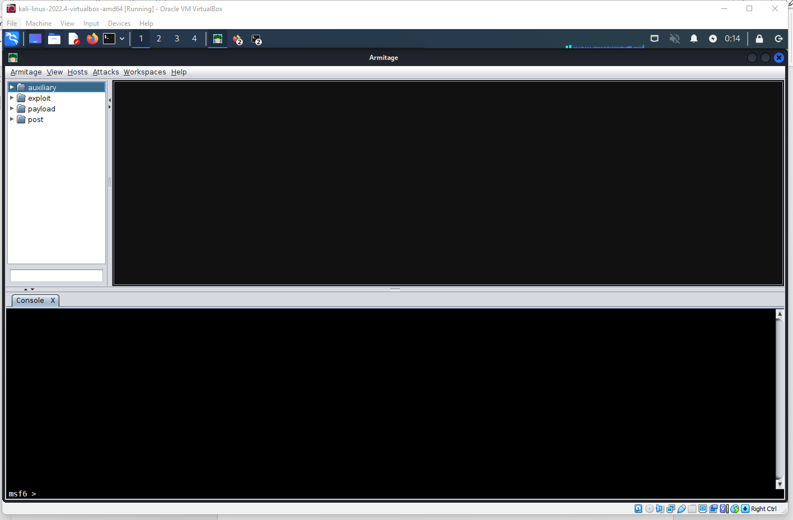
If you don’t have targets you will create them.
Run metasploitable 2 in your virtual box.
In the command line run the command
ifconfig
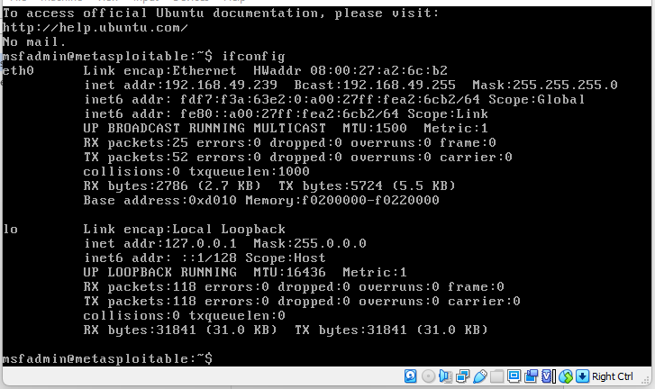

You will see IP address of this target machine (metasploitable 2)
It is 192.168.49.239

We shall do an Nmap scan of the network, using the target as 192.168.13.130. To accomplish this task, select “Hosts > Nmap Scans > Intense scans”. Various scan options are available, as bundled with the regular Nmap tool, and these can be executed as and when needed. A new scan window opens adjacent to the console, displaying the GUI activities. It identifies all the open ports and services running on them, grabs the banners and identifies the OS on the target.

After first scan complete you will have the following:

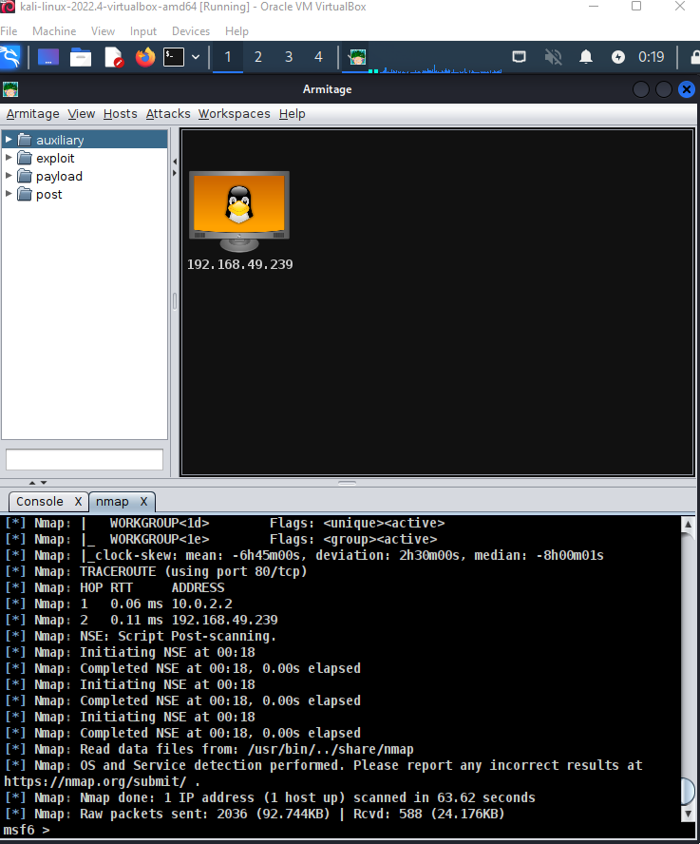

Those icons are the result of defining a workspace and machines in it. The `workspace' tab is used for this purpose. Armitage uses nmap to scan machines for services. Once that is done, attacks can be suggested for each machines. This is done by selecting one of the icons, dropping the `Attacks' menu as shown below, and selecting `Find Attacks'.

Now an `Attack' menu is made available for the selected icon. This can be accessed with a right click over the selected icon. Doing so allows one to choose an attack as illustrated below.

So naturally, you go to Attacks -> Find Attacks and click it. The Find Attacks option is supposed to generate custom attacks for each target you scan, but no exploits load in.
Armitage then prompts:
"Attack Analysis Complete... You will now see an 'Attack' menu attached to each host in the Targets window. Happy hunting".
However, when you right click on your target, no such menu appears.
Everything else seems to be working fine. Why is this happening? I cannot tell you why, but my guess is because Armitage is an outdated Java program. Thankfully I can tell you how to fix it.

However, if don’t see attack menu attached to the icon check this out https://jacobmarabelli.com/use-this-simple-workaround-if-armitages-find-attack-option-breaks-2022
Or just do the following:

If you go up to the top left corner and click on Armitage, you should see a drop-down menu. Make sure Set Exploit Rank is set to Poor. Do this and your attacks should begin populating.
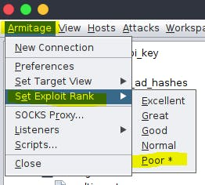
Now you should see the following:

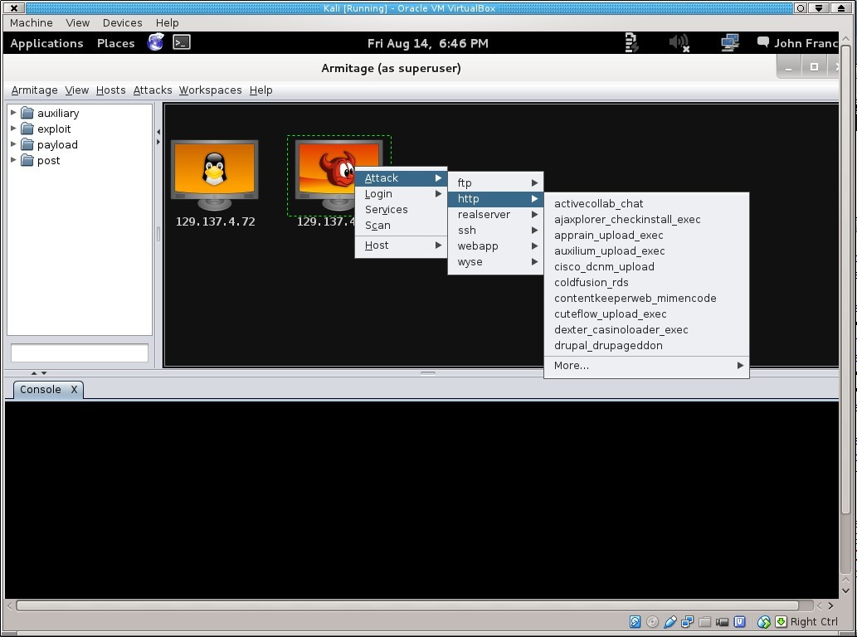
Selecting an attack results in a window, such as the one below, where parameters can be set.

You can attack using different exploits and payloads.
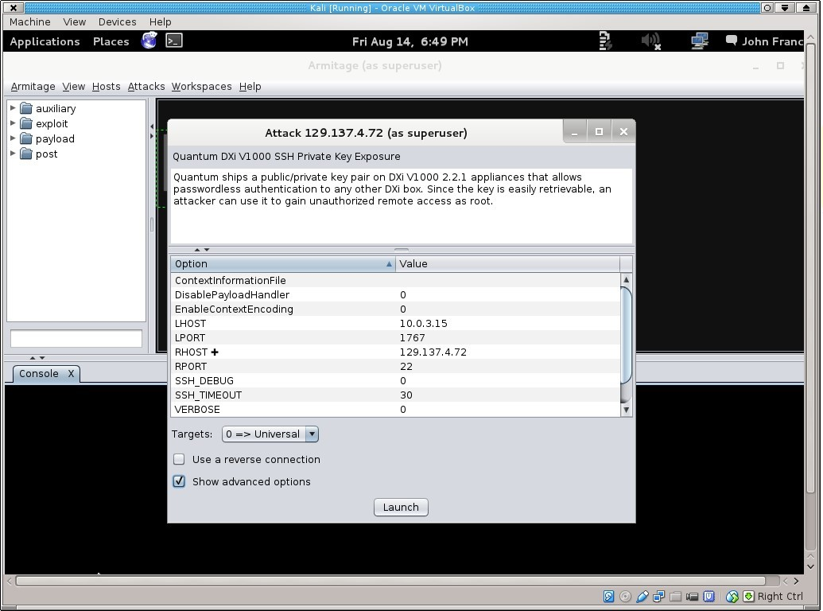
When the attack is launched, progress and results are displayed in the bottom window.
Attacks could not be successful. Sometimes they are successful. Good luck!
The following are examples of different attacks:

Attack # 1.
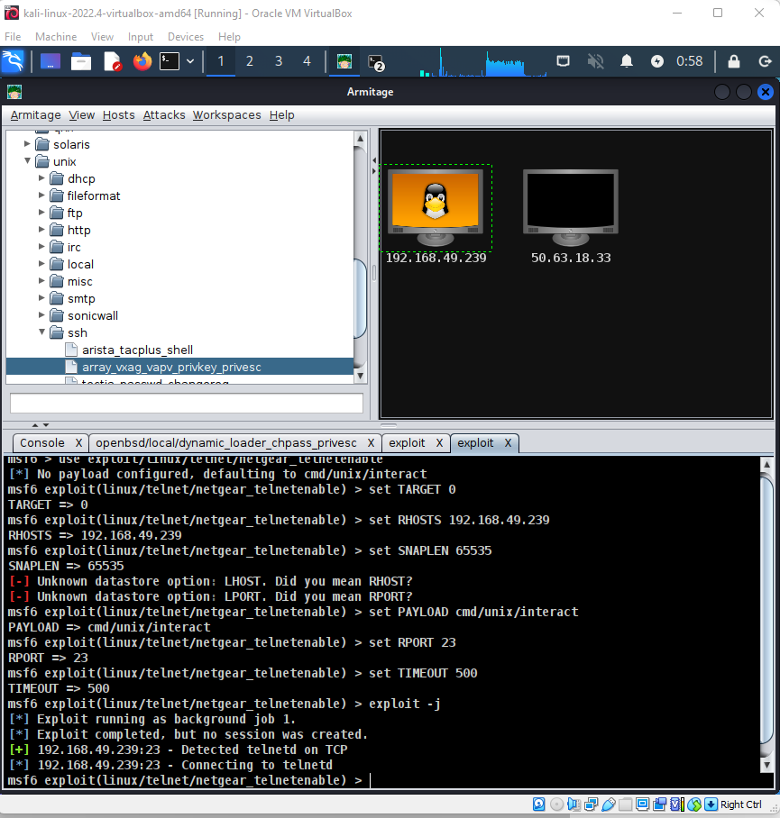

Attack # 2.

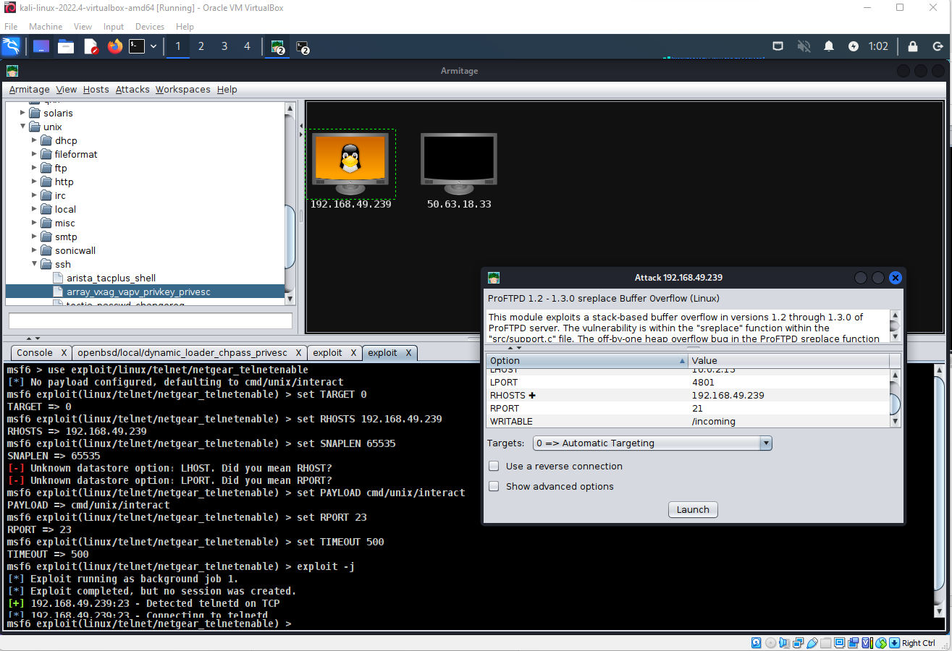

Result:
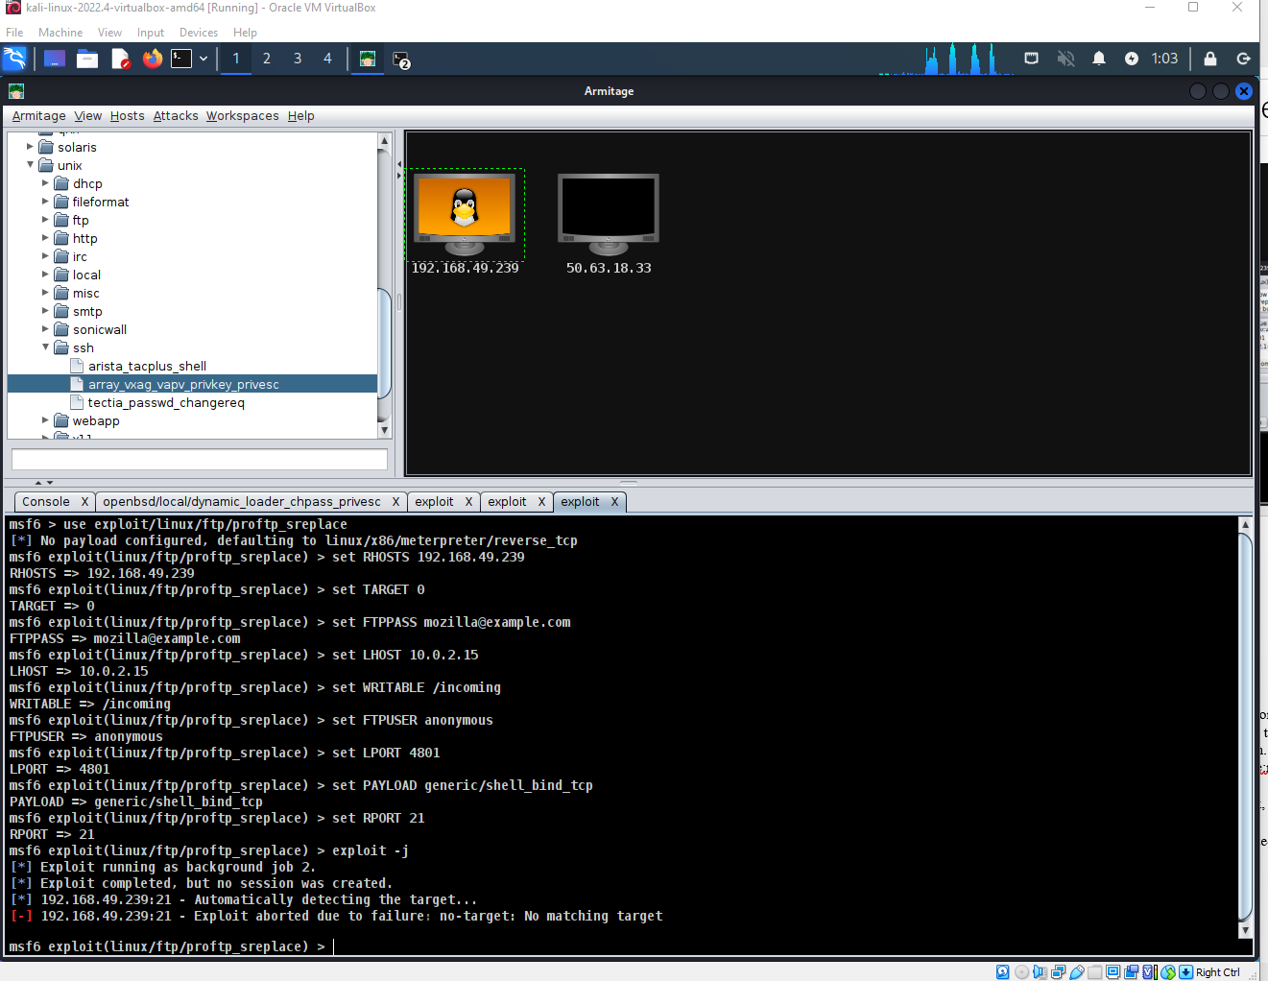

Attack # 3:

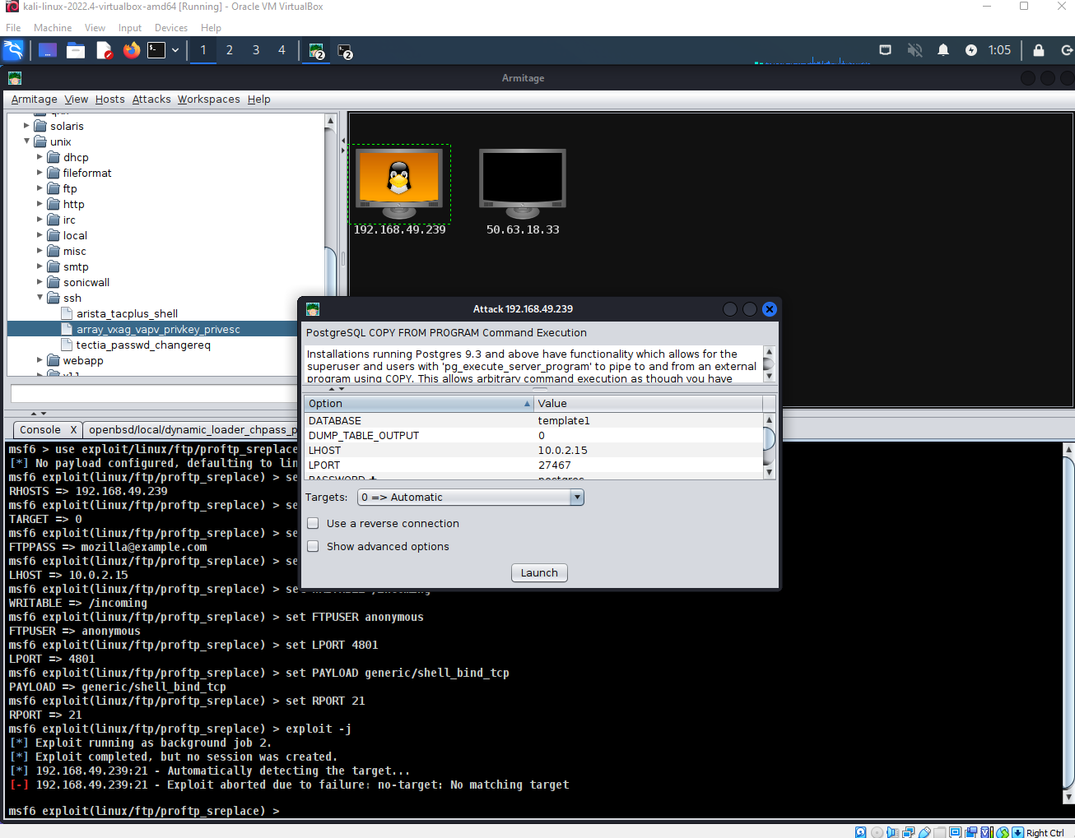

Result:

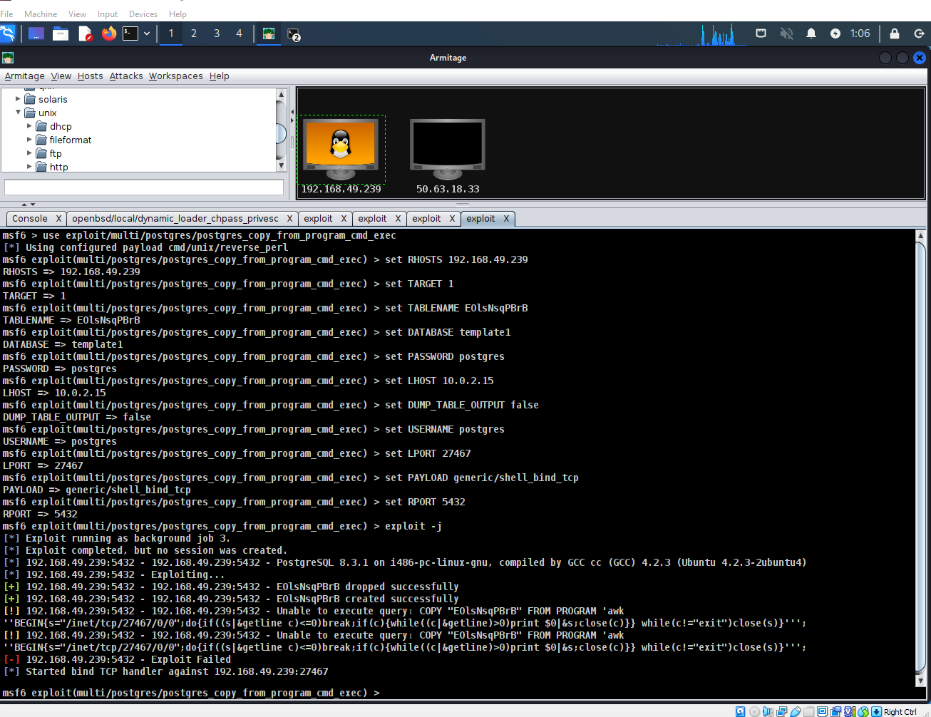

Attack # 4.
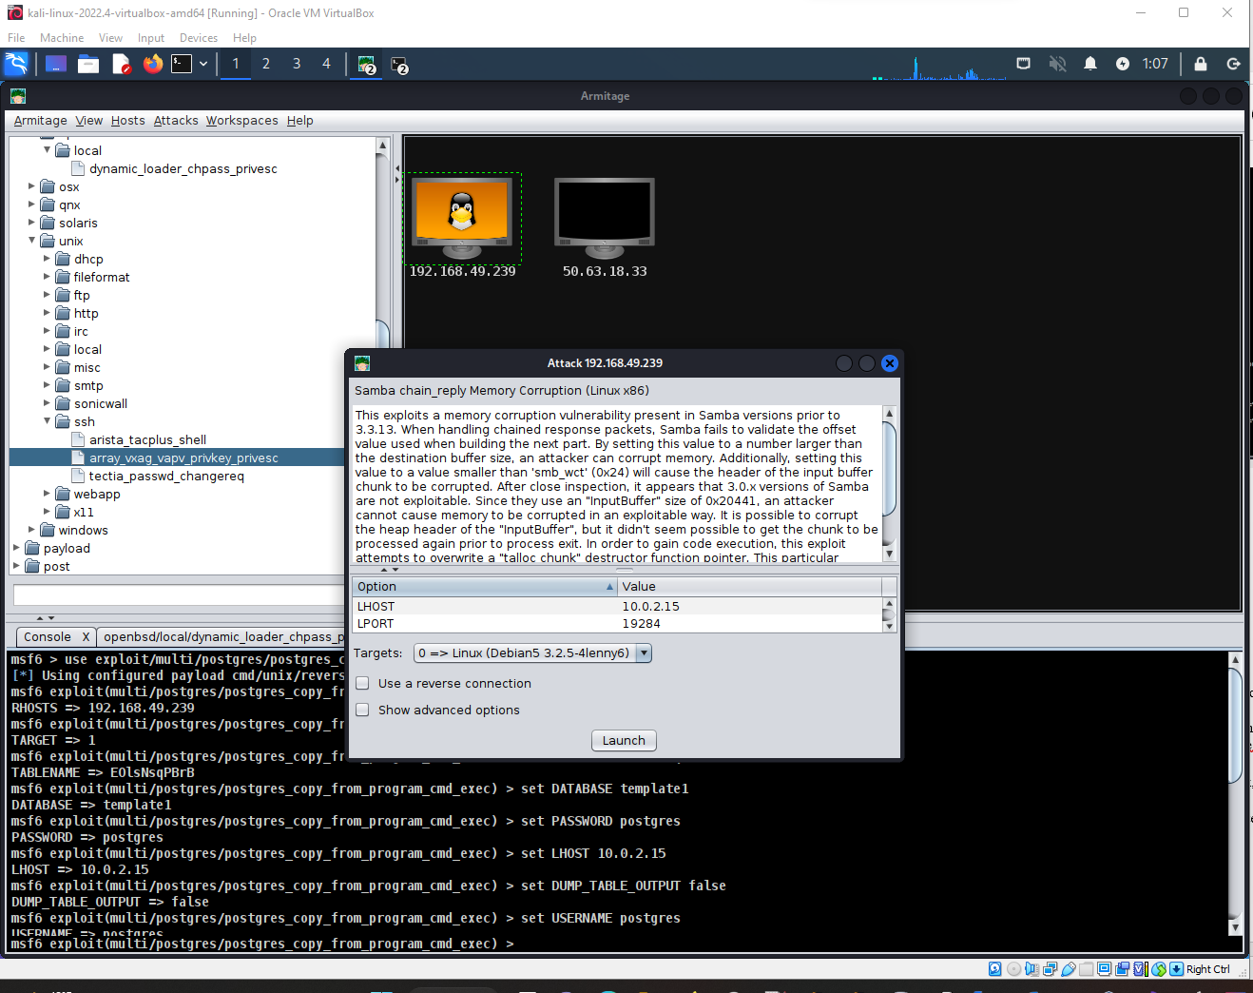

Result:

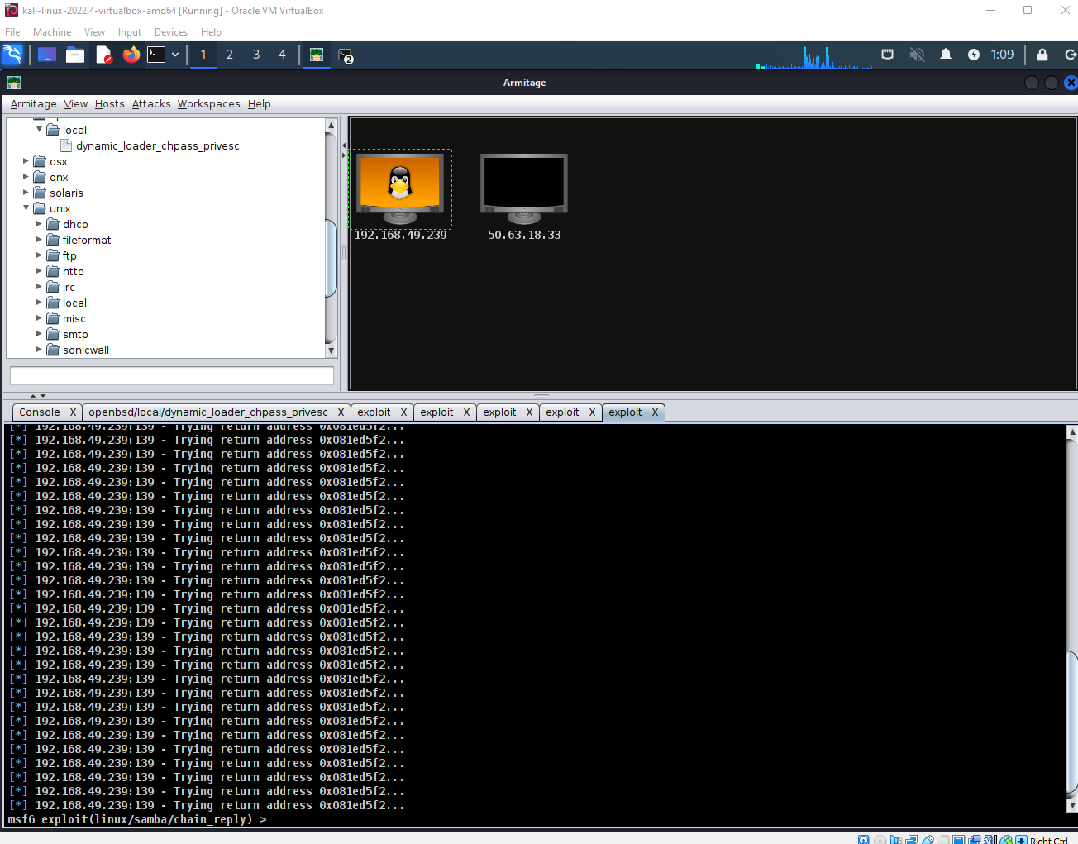

The Exercise

Downloand Metasploitable 2 for a virtual box.
Open virtualbox. Import the appliance to virtualbox by clicking 'File', then 'Import Client' from the menu. On the right side of the dialog box that opens there is a small square icon. Click that to open a File Dialog box and search for and select the appliance. Click 'Next' to begin the installation. Use armitage from a second VM to try attacks on that OS. Login to the metasploitable OS (username:msfadmin password:msfadmin) and find other vulnerabilities.
Submit a lab report detailing up to 5 suspicious findings in a list. If there is a fix, state the fix in the list.
Try exploits where possible. Document commands used and take screenshots.
Note that metasploit and Armitage exist in Kali Linux but they need to be updated.
Please submit two or three screenshots of the report. Thank you!

